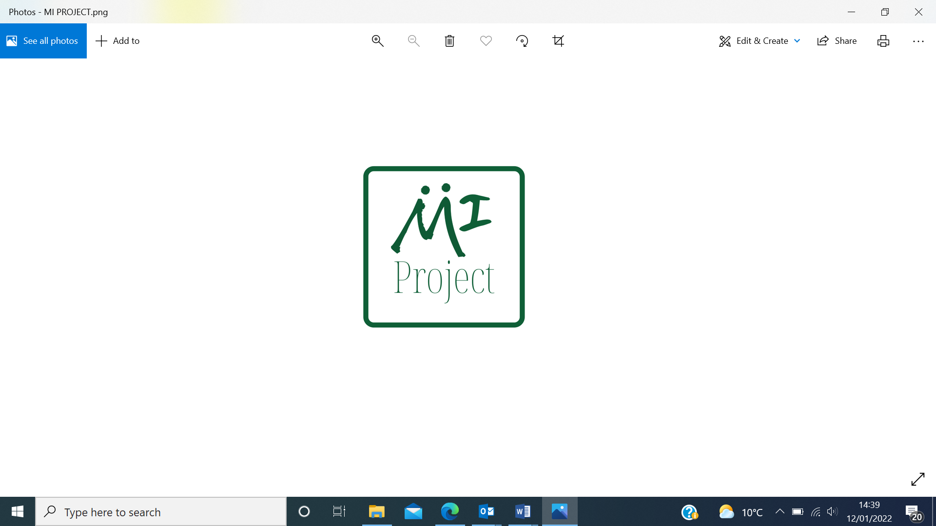

**Young People’s IDVA Service**

**This is a service for young people aged 13 - 24 years who are experiencing domestic abuse in their own interpersonal relationship.**

We offer 1-1 support to enable young people to make informed choices around their relationship, offer support to increase safety from domestic abuse, work through their feelings and identify the impact the abuse is having on their lives.

The direct work will be a client led approach that will allow young people to explore the relationship between power and control abuse and toxic relationships, developing their understanding of healthy and unhealthy relationships.

Support will be provided to help recognise signs of domestic abuse and unhealthy relationships and be aware of how to respond to domestic abuse.

The Young Person’s IDVA will provide a safe space to challenge societal norms and gendered beliefs, increasing confidence and self-esteem.   
  
We provide safety planning advice and support; this includes information on safety services that are available to a young person.   
  
The Young Person’s IDVA will liaise with other professionals, to voice their views, wishes, feelings and queries.

We recognise that not everyone wants to or is ready to take action and we will support you to remain as safe as possible, whether you decide to remain in your interpersonal relationship or not.

The Young People’s IDVA recognise that telling someone about abuse is not easy, they are here to listen and support you.



**Young Person IDVA Referral Form**

**Referral care pathway criteria:**

Young people can self-refer by calling 01642 241864 or emailing their contact details to: [reception@mysistersplace.co.uk](mailto:reception@mysistersplace.co.uk)

Professionals based in Secondary schools, Colleges, Youth Clubs, and other youth-based settings can submit the referral with consent from the young person. Referrals are also accepted from Middlesbrough Local Authority services.

**How to complete this referral:**

Please complete all areas of information included on the referral form with consent from the young person. By completing the required information in the referral form, this assists in establishing safe contact with the young person in timely manner.

**How to submit this referral:**

Send fully completed referrals to

My Sisters Place,

123 Borough Road

Middlesbrough

TS1 3AN

Email: [reception@mysistersplace.co.uk](mailto:reception@mysistersplace.co.uk)

If you have a CJSM Secure E-mail system, please send this form securely to [admin.msp@msp.cjsm.net](mailto:admin.msp@msp.cjsm.net)

**Eligibility criteria for this service:**

*Please ensure that the client meets the following criteria prior to submitting the referral:*

The Young Person is aged between 13-24 years and are experiencing domestic abuse within their own interpersonal relationship.

The young person is current to Middlesbrough services or resides in the Middlesbrough area.

Consent has been obtained from the young person to access the service.

**How to get in touch:**

If you have any questions about our service, eligibility criteria, or how to make a referral, please contact reception on 01642 241864 or email reception@mysistersplace.co.uk

|  |  |
| --- | --- |
| **Information about the person making the referral** | |
|  | |
| Date of referral: |  |
| **Please enter your name and contact details:** | |
| Referrer’s name: |  |
| Organisation name and address: |  |
| Role/ job title: |  |
| Contact number: |  |
| Contact email: |  |

**Client contact information**

|  |  |  |  |  |  |  |  |
| --- | --- | --- | --- | --- | --- | --- | --- |
| **Contact information** | | | | | | | |
| Clients name: | | | |  | | | |
| Preferred name? | | | |  | | | |
| Have they been known by any other names? | | | |  | | | |
| DOB: | | | |  | | | |
| NI Number: (if known) | | | |  | | | |
| Telephone number: | | | |  | | | |
| Email address: | | | |  | | | |
| Has the client consented to the referral? | | | | Yes / No | | | |
| **Addresses** | | | | | | | |
| Current address | | | |  | | | |
| Current Local Authority | | | |  | | | |
| Local Authority of origin (if different) | | | |  | | | |
| What it the best method to contact the client and are there any safety issues? | | | |  | | | |
| **Next of kin – who can we contact in an emergency?** | | | | | | | |
| Name | | |  | | | Relationship |  |
| Contact information | | |  | | | | |
| Safe contact notes | | |  | | | | |
| **Accessibility requirements** | | | | | | | |
| Does this client have any accessibility requirements (i.e. disability or language barrier? | | Yes ☐  No☐  Don’t Know ☐ | | | *If yes, please provide details:* | | |
| **Information about the alleged perpetrator, if known:** | | | | | | | | | |
| Name: | |  | | | | | | | |
| DOB: | |  | | | | | | | |
| Relationship to client: | |  | | | | | | | |
| Address | |  | | | | | | | |

**Client support needs / vulnerabilities**

|  |  |
| --- | --- |
| ***Please tell us more about any support needs the client may have:*** | |
| Mental Health ☐  Physical Health ☐ | Substance misuse ☐  Offending ☐ |
| **Additional details:** | |
|  | |
| Are they pregnant? | Yes ☐ No ☐ Don’t know ☐ |
| What is this client’s nationality? |  |
| *(If not British National)* What is their immigration status? |  |
| *(If not a British National)* Do they have access to Public Funds? | Yes ☐ No ☐ Don’t know ☐ |

**Services involved with the young person**

|  |
| --- |
| ***Please state what services the young person is currently engaging with?*** |
| **Additional details:** |
|  |
| ***Please state if the young person is open to a child protection plan, does the young person have a social worker involved in their care?*** |
| **Additional details:** |
|  |

**Client equalities monitoring**

|  |  |
| --- | --- |
| How would this client describe their gender? | Female ☐  Male ☐  In another way:_________________ |
| Is their current gender different to the sex they were assigned at birth? | Yes ☐  No ☐  Don’t know ☐ |
| Do they consider themselves to have any kind of disability?  (please tick any that apply) | Physical ☐  Learning ☐  Mental Health ☐  Deaf/ hearing impaired ☐  Blind/ visually impaired ☐  Something else: _________________  Don’t Know ☐ |
| How would they describe their ethnicity? | |
| White British ☐  White Irish ☐  White Gypsy or Irish Traveller ☐  Any other White background ☐  Asian British ☐  Asian Indian ☐  Asian Pakistani ☐  Asian Bangladeshi ☐  Any other Asian background ☐  Chinese ☐  Arab ☐ | White and Black Caribbean ☐  White and Black African ☐  White and Asian ☐  Any other mixed/ multiple background ☐  Black British ☐  Black African ☐  Black Caribbean ☐  Any other Black background ☐  Other (please specify):  _________________________  Don’t Know ☐ |
| Do they have a faith/ religion? | |
| Buddhist ☐  Christian ☐  Hindu ☐  Jewish ☐  Sikh ☐ | No religion ☐  Don’t Know ☐  Other:  ______________________________ |
| What is their relationship status?  (tick one option) | Civil partnership ☐  Married ☐  Divorced ☐  Separated ☐  Cohabiting ☐  In a relationship (not cohabiting) ☐  Widowed ☐  Single ☐ |
| What is their sexual orientation?  (tick one option) | Heterosexual/ straight ☐  Gay woman/ Lesbian ☐  Bisexual ☐  Something else: _________________  Don’t Know ☐ |

**Reason for referral**

|  |
| --- |
| **Reasons as to why are you making this referral – how could this young person benefit from our support? What is the outcome you hope to achieve from the referral?** |
|  |
| **Are there any known risks to working with this client?** |
|  |

|  |  |
| --- | --- |
| ***OFFICE USE ONLY*** | |
| ***Referral outcome*** | |
| Referral accepted? | Yes ☐  No ☐ |
| Allocated to: |  |
| **Please complete if the referral was rejected** | |
| Reason for rejection | Unable to contact client ☐  Client does not want support ☐  No space/ capacity to support ☐  Ineligible for support (age) ☐  Ineligible for support (borough) ☐  Ineligible for support (service description) ☐  Identified as unsafe to work with ☐  Identified as perpetrator ☐  Unable to meet support needs around language ☐  Unable to meet support needs around large family ☐  Unable to meet support needs around mental health ☐  Unable to meet support needs around disability ☐  Unable to meet support needs around NRPF ☐  Unable to meet support needs around drug and alcohol ☐  Previous convictions for violent/sexual offences/ arson ☐  Other ☐ |
| Referred/ signposted on to: | Another refuge ☐  Another specialist VAWG service ☐  NDVH ☐  Non-VAWG organisation/ service ☐  Other ☐ |